<Things I did>
PCB Stackup Design
Things to keep in mind
Signal Layer: contains predominantly signal carrying traces
Power/GND Layers: Typically completely solid copper pours over entire layer
- For low-speed and low bandwidth systems you can route power with traces on signal layers

Power supplies needed:
Fully Differential Op-Amp
- VCC5V
- VOC2.5V
- Bias1.65V
- GND
Receivers: Need to check what VCC is – discussed with Eyke, it should be
- VCC3.3V
- GND
Transmitters:
- VCC3.3V
- GND
Overcurrent Detection:
- VCC3.3V
- GND

  - 2.5V for common mode
  - 1.65V for voltage offset
  - 5V supply for Differential Op-Amp -> Analog Signals
  - 3.3V for Digital signals

Questions:
- On the symbol for U5, there are green x marks indicating that a design rule has been ✅ broken. I didn’t do anything, the footprint was already like that – how do I proceed
- Connector and board shape✅
- Origin – parts cannot be moved beyond in the minus direction✅
- It took hours to get everything imported into PCB from the schematic✅

- I did not understand what you meant by this message:

- For some reason there are now 2 AnalogMeasuremens in BitBucket
- +5V Power Disabled? 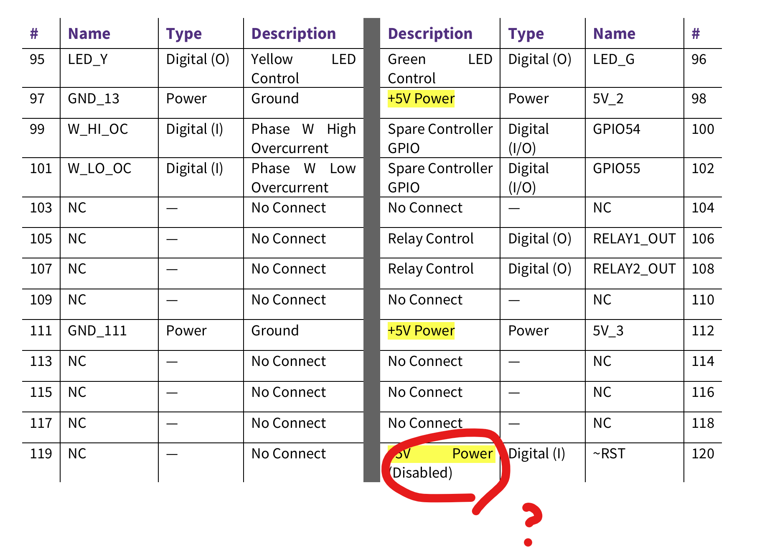
- Here the Ports are going out in both directions. Is this the convention?
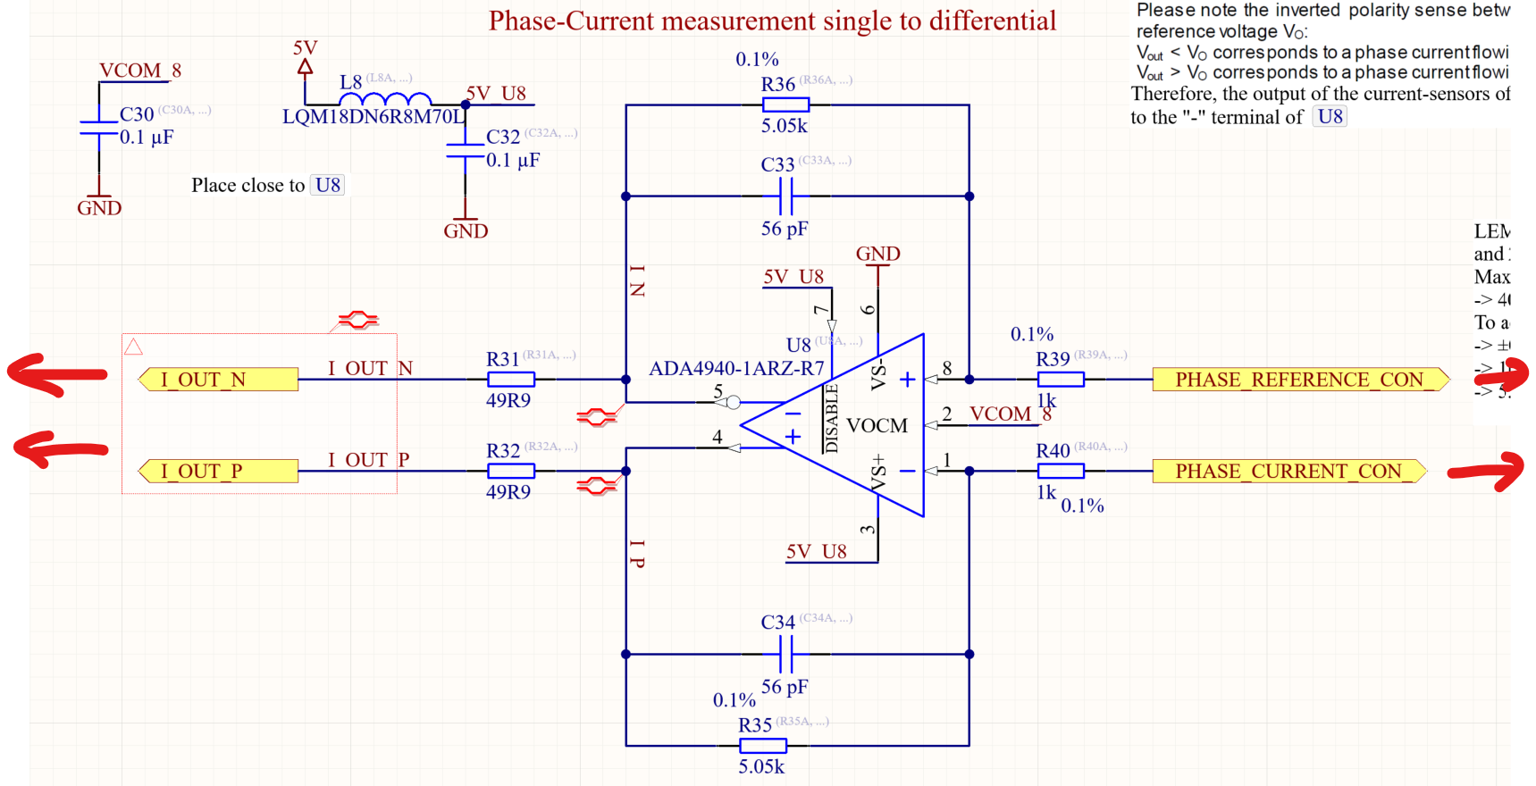

- What type of IC package should I use? ✅ - SMD (Surface Mount Device)
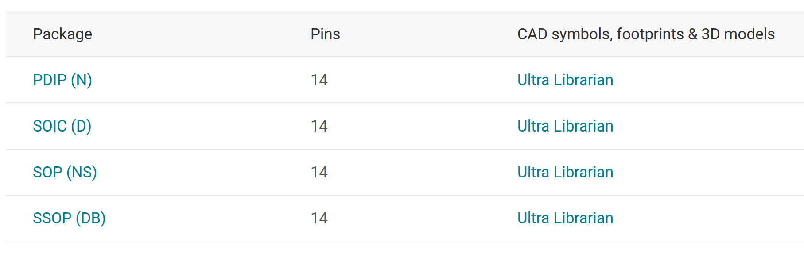
Through hole mounting or surface mounting?

- For the power schematic
  - Can I use simple voltage dividers or should I use switching voltage regulators?
    - We need 5 power levels: GND, VCC5V, VCC3.3V, VCM2.5V, 1.65V bias
      - Understand how much current we are getting from 5V
        - From inverter board
    - Connection from the connector. The connector_inverter has the 5V inputs but how can I place that in my power schematic? Just with a normal circle style power port?
  - Filter for in the +5V_Power input coming in from the connector_inverter?
    - Or can we assume it is stable enough

Meeting Minutes:
Library settings for all components schematics and footprints
- Design -> Make Schematic Library
  - Search first what this does and then implement
  - Hopefully it will take all the parts from the project and make a library
    - Then link the library directly like I did the uz_users.lib
Change the project name itself as well as the name of the pcb file
Power Supply
- We have 5V from the inverter (we don’t need to have a filter or anything?) There are many methods to get from this 5V to the different voltage levels that we want
  - Linear Regulator
  - Buck converter
- First we need to know what our budget is: we have 5V input from inverter at 1A
- Determine the current needed for each of the components that need different level power supply
  - The actual current pulled during operations and also quiescent current
  - Can look at datasheet and also LTSpice Simulation
  - The total current pulled should not exceed the budget (here ex. 1A)
- It is important that we have many test points
  - Put an external 5V input pin header so that we can cut off the input (ferride beads) from the inverter
    - Ferride beads are really small pass through inductors that can be connected in series to the 5V input from the inverter so that that 5V supply can be cut off
- 5V -> 3.3V: Find linear regulator
  - Check all the 3.3V supplied components and estimate what the currents will be
- 5V -> 2.5V: Find linear regulator
  - Check simulation for current values
- Choose a linear regulator (look up how and what points should be kept in mind when doing this)

AND Gates, use SMD surface mount✅
https://www.ti.com/product/de-de/SN74HCS08
SN74HCS08

LTSpice troubleshooting -DO NEXT – NEEDED TO ESTIMATE ALL THE CURRENT ASSUMPTIONS

